

**Bachelor of ICT Assessment Cover Sheet**

**Course Code and Title:**

IT8406 – DATABASE ADMINISTRATION

**Assessment Title:**

**The following learning outcomes will be assessed:**

1. Install and configure an enterprise database to provide a solution for a

given customer requirement following industry best practices.

2. Plan and implement security policies and procedures to ensure data

integrity.

3. Perform database maintenance tasks to optimize system performance.

Group Project

**Student ID**

202000270 - 202002514 - 201901982

**Student Names:**

-Ameena Adel Mohammed Almohanna

-Fedaa Abdulwahab

-Maryam alali

**Tutor:**

David Gulua

**Due Date:**

Friday, 4th of January 2024

***By submitting this assessment for marking, either electronically or as hard copy, I confirm the following:***

* *This assignment is* ***my own work.***

#### Any information used has been properly referenced.

* *I understand that a copy of my work may be used for moderation.*

#### I have kept a copy of this assignment.

Do not write below this line. For Polytechnic use only*.*

**Assessor:**

**Date of Marking:**

**Grade/Mark:**

**Table of Contents**

**Business Analysis** 3

Ameena: - 3

About the company 3

Problems and needs 3

Fedaa: - 5

Maryam: - 5

**Solution Description/rationale** 5

Ameena: - 5

On-Premises – Full local 5

Fedaa: - 6

Hybrid cloud 6

Maryam: - 6

Cloud 6

Final solution 6

**Project Plan/ Timeline** 7

Phase one: Project planning 7

Phase two: Business analysis 7

Phase three: Solution description 7

Phase four: Project budget 7

Phase five: Project execution 8

Phase six: Project reflection 8

Phase seven: Review and submit 8

**Project Budget** 9

Ameena: - 9

Fedaa 10

Maryam 10

Final budget 11

**Project Execution** 11

**Virtual Environment creation** 11

**Database creation** 11

**Managing data** 11

**Data Guard** 11

**Testing** 11

**Project Reflection** 11

Ameena: - 11

Fedaa 12

Maryam 12

**References** 13

# **Business Analysis**

## Ameena: -

### About the company

A large delivery organization in Bahrain consisting of 6,000 online users and 300 staff operates on Oracle databases for two of its main information systems. These systems are the Online Delivery Information System and the Human Resource Planning System. The online Delivery Information System's current version runs on a single instance of an outdated Oracle 11G database. The system is used by both users and 100 of the staff such as the Customer Relationship Department that supports the operational business process of the company. While the Human Resource Planning System 's current version is Oracle 19C Enterprise Edition database, which contains 20 employee profiles and information stored in a single pluggable database serving the HR department as well as the remaining 270 employees.

### Problems and needs

Based on the analysis of the project brief, it is clear that the delivery company has multiple serious database infrastructure issues and requirements such as:

**Old database:** The online Delivery Information System uses an outdated Oracle 11G database which is no longer supported and incompatible with the newest database upgrade Oracle 19c which is implemented by the application vendor, putting customer data at risk. Therefore, the software must be upgraded to Oracle 19C to support their latest releases, enhance security, and gain new features. For example, according to the case study by Data Intensity (2023), the American Industries group has benefited from upgrading to Oracle 19c database, which provided active Oracle support and improved security and performance.

**Availability level and a standby database:** the system must be available 24*7 to handle the organization's transactions and reporting requirements. Thus, a standby database is required with the usage of Oracle Data guard to prevent the risk of losing data, downtime and avoid any failure (“Oracle (Active) Data Guard 19c”, 2019).

**Information Infrastructure Improvement:** The business needs to have the availability of data infrastructure development and test environments for effective execution and testing of database solutions.

**Multi-tenant Architecture:** The Human Resource Planning system works as a single instance, increasing maintenance costs, less flexibility, limited scalability, resource inefficiencies and higher maintenance and operational costs. By moving this system to a multi-tenant architecture, hardware and maintenance costs can be reduced as it is mentioned in the case study, even though the migration from a single tenant to a multi-tenant system requires some reengineering efforts, there are far more benefits (Hossain & Shirazi, 2015).

Meanwhile, the volume of data is increasing rapidly, and existing resources cannot handle it because Oracle databases are currently running on old on-premises servers where high-availability databases require more servers and multiple Oracle instances are running on different servers to host different databases with a limited budget for purchasing new hardware and software, as well as for deployment and maintenance. Moreover, no Oracle development environment is available for five software developers and no Oracle testing environment is available for 15 testers for implementing and testing new software products based on Oracle databases.

The organization needs cost-effective, efficient, scalable, continuous availability, minimal downtime for maintenance, information security, high performance, less redundancies, and upgradeable solution.

## Fedaa: -

## Maryam: -

# **Solution Description/rationale**

Different solutions can be deployed for the delivery company like On-Premises, Cloud and Hybrid cloud. Each solution has advantages and disadvantages. However, depending on the company’s needs, a suitable solution will be implemented.

## Ameena: -

### On-Premises – Full local

Implementing a new, high-availability, cost-effective Oracle database environment can be achieved by switching from a single-instance to multi-tenant architecture, keeping the database fully local and creating and managing database mirror copies using Oracle Data Guard. Therefore, the database should be moved to a more powerful server.

This solution grants the organization full control over its data and infrastructure by managing and hosting all aspects of the technology locally such as servers, software, and databases, as it is located on company property. It is ideal for organizations with strict compliance, security policies and desire to access their databases quickly (Layer, 2022).

Pros: -

- Total control over the infrastructure and security measures.

- Highly customizable to meet specific needs.

- Consistent and predictable costs.

- Ensure excellent performance and fast access.

- Protection of data which remains on premises.

Cons: -

- Initial expensive Costs.

- Software and hardware maintenance can be time-consuming and demand specialist.

-Scaling up can be costly and complicated.

## Fedaa: -

### Hybrid cloud

## Maryam: -

### Cloud

## Final solution

We chose an on-premises system and located it physically. The main multitenant database will be hosted on a strong server. In comparison with the other proposed solutions provided by the group members, this solution is more suitable for cost, operation requirements and more reliable as it will not be affected if one day the server that is in cloud closed. Furthermore, the solution chosen is incredibly customizable, optimized well and more secure for sensitive data. Maintenance or failure will only require a short downtime to switch to the local standby database. Because the current system runs on a fully physical on-premises server, it is possible to implement or upgrade the necessary infrastructure such as power, network, and server rooms which are present and could be adjusted for the new system more efficiently and with less time consumed than reconfiguring all to use a different solution.

# **Project Plan/ Timeline**

The project will be divided into seven phases. The Excel schedule below shows project progress, including the task name, duration of the task, start and end dates, task dependencies, and member responsibilities (see **Table 1.1**).

## Phase one: Project planning

The project started with discussions about each member's understanding of the requirements, identifying each member's role, and creating a detailed Excel table based on a timeline prediction, starting on 10/17/2023 and ending on 1/4/2024 and highlighting dependencies for each phase.

## Phase two: Business analysis

During this phase, each member analyzes the business problem by collecting relevant research materials, listing important information from the project brief, and identifying the company's problems.

## Phase three: Solution description

This phase includes providing solutions to the business issue by evaluating the advantages and disadvantages of each solution and choosing the best option.

## Phase four: Project budget

This phase contains the calculation of the total cost of the solution over five years and a cost estimate for new servers or resources, such as hardware and cloud services in a detailed budget plan.

## Phase five: Project execution

This phase involves the implementation of the selected solution, as well as database and standby deployments, ensuring that the project is proceeding as planned within budget and that any challenges are addressed.

## Phase six: Project reflection

This part consists of a reflection on lessons and experiences gained throughout the project, the problems that are faced, how to overcome them and suggestions for improvement.

## Phase seven: Review and submit

The last phase includes reviewing and all project phases for accuracy, preparing the final project folder, and finally submitting the project.

**Table 1.1**

The project plan in Excel shows details of the workflow.

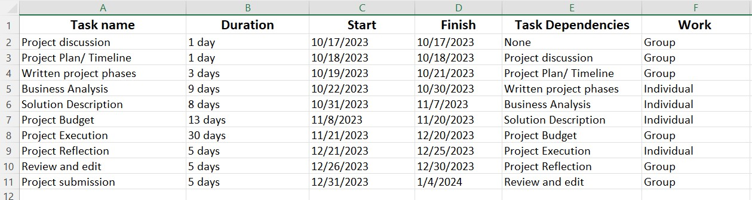

# **Project Budget**

## Ameena: -

PowerEdge R7515 Rack server which costs $2,529.00 or 953.39 BHD, the Dell PowerEdge servers powered by 3rd Generation AMD EPYC is fast, has more competitive outcomes, efficient data center manageability and end-to-end infrastructure security.

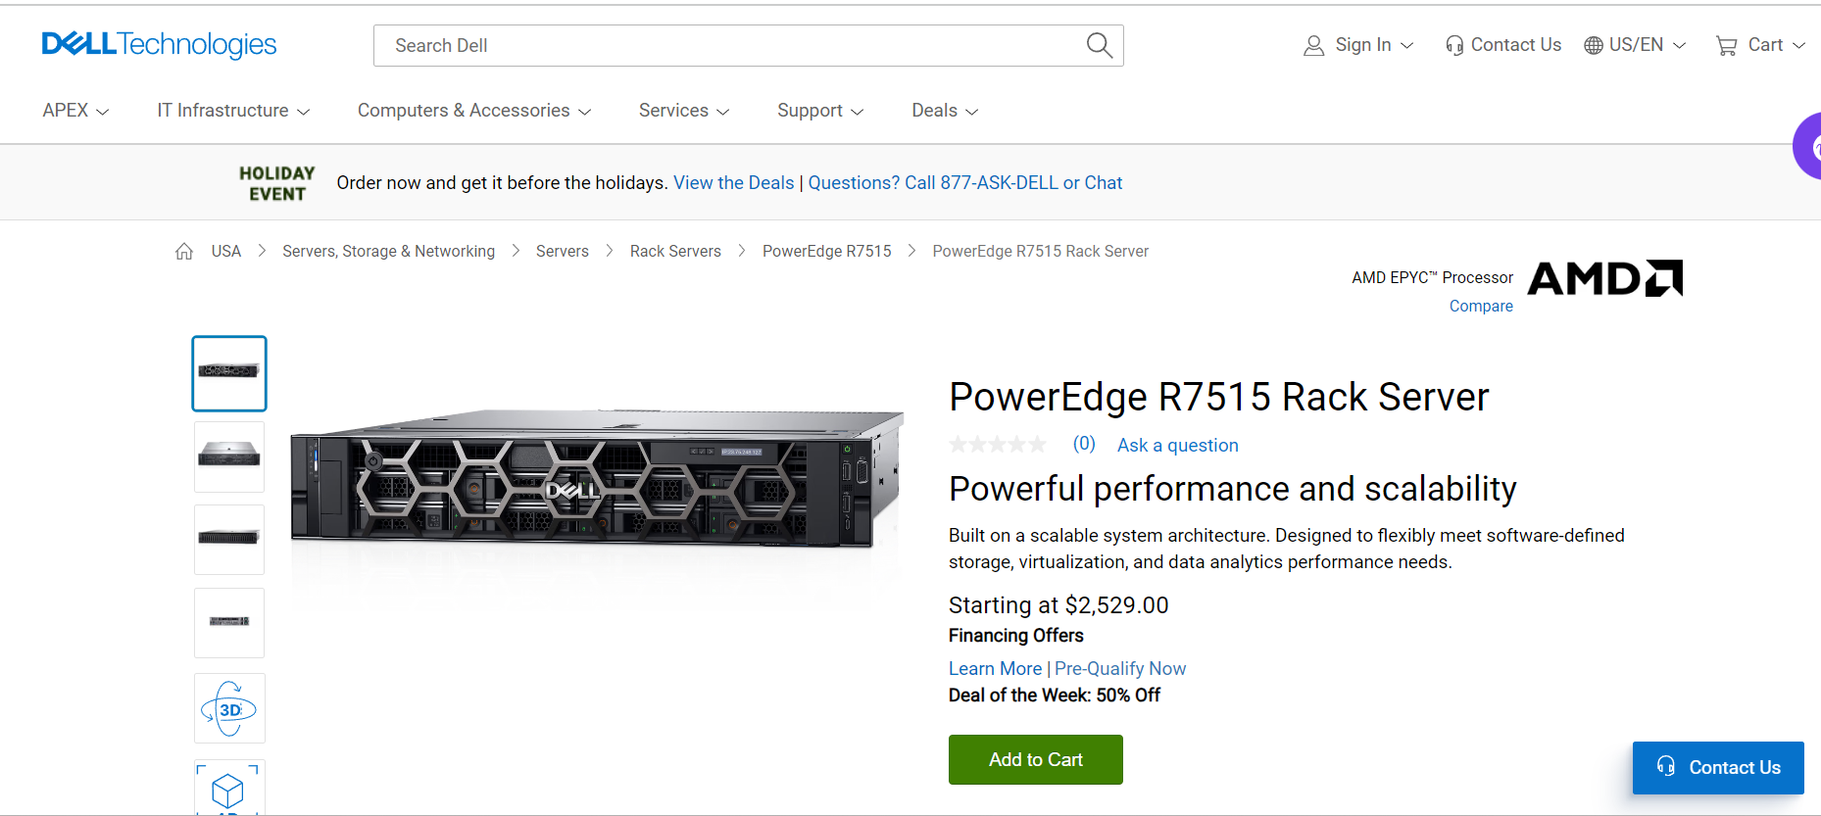

The budget was calculated using the Oracle price list (“Oracle,” 2018), Oracle core-factor table (“Oracle,” 2023) and using DB calculator (“Oracle DB Licensing Calculator - WintelGuy.com,” 2016). I will choose solution two with minimum NUP : 800 because it costs less for now : 109303040.58 BHD and if needed in the future we can increase the number of users license (See Figure 1.1).

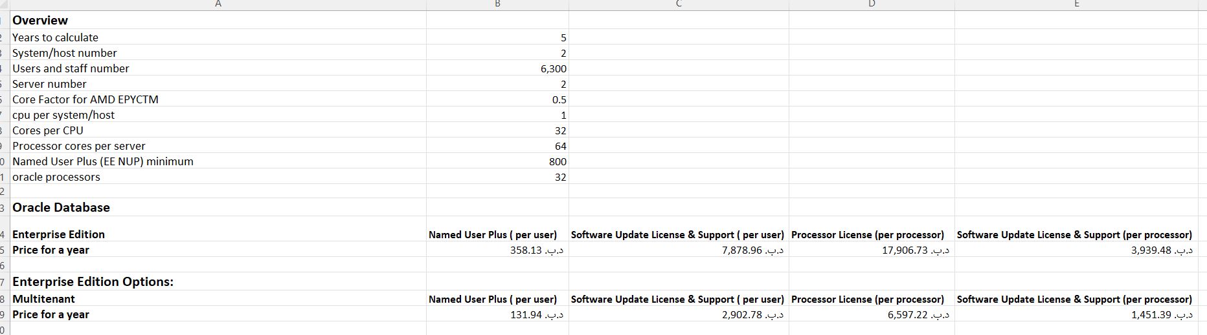

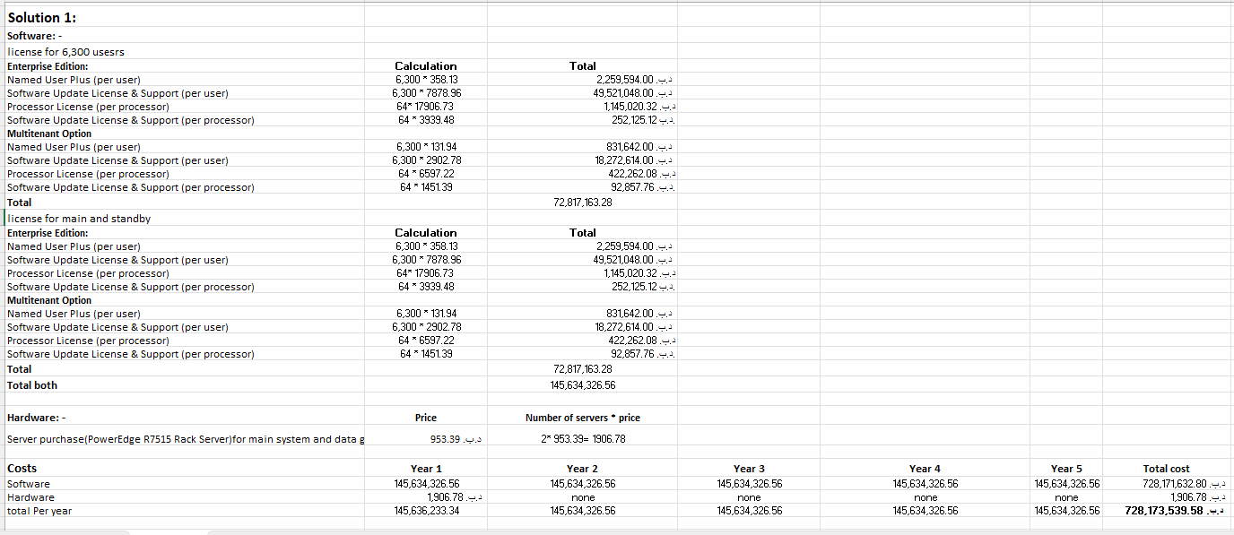

**Figure 1.1** shows two solutions for full local budget, one with actual users and one with NUP minimum.

## Fedaa

**Figure 2.1** The table below shows the Hybrid cloud budget.

## Maryam

**Figure 3.1** The table below shows the Cloud budget.

## Final budget

The budget for the chosen solution (See Figure 1.1) in Amena section.

# **Project Execution**

## **Virtual Environment creation**

## **Database creation**

Creating a database using the DBCA “Database configuration assistant” in putty primary machine. Database name is “pdbgrp1” for the online order and delivery database “dpdbgrp1”.

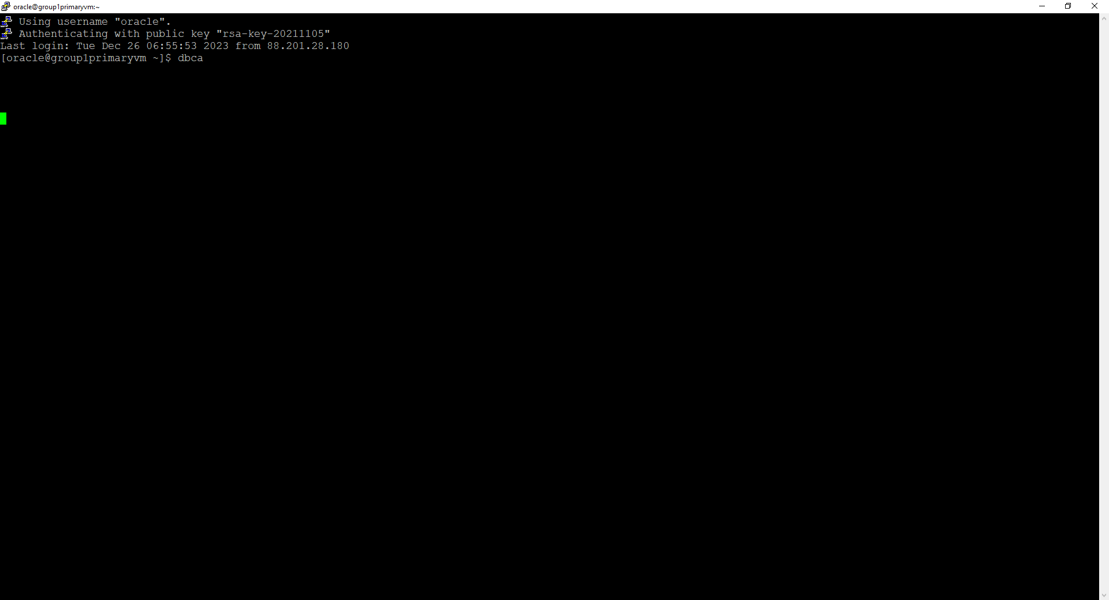

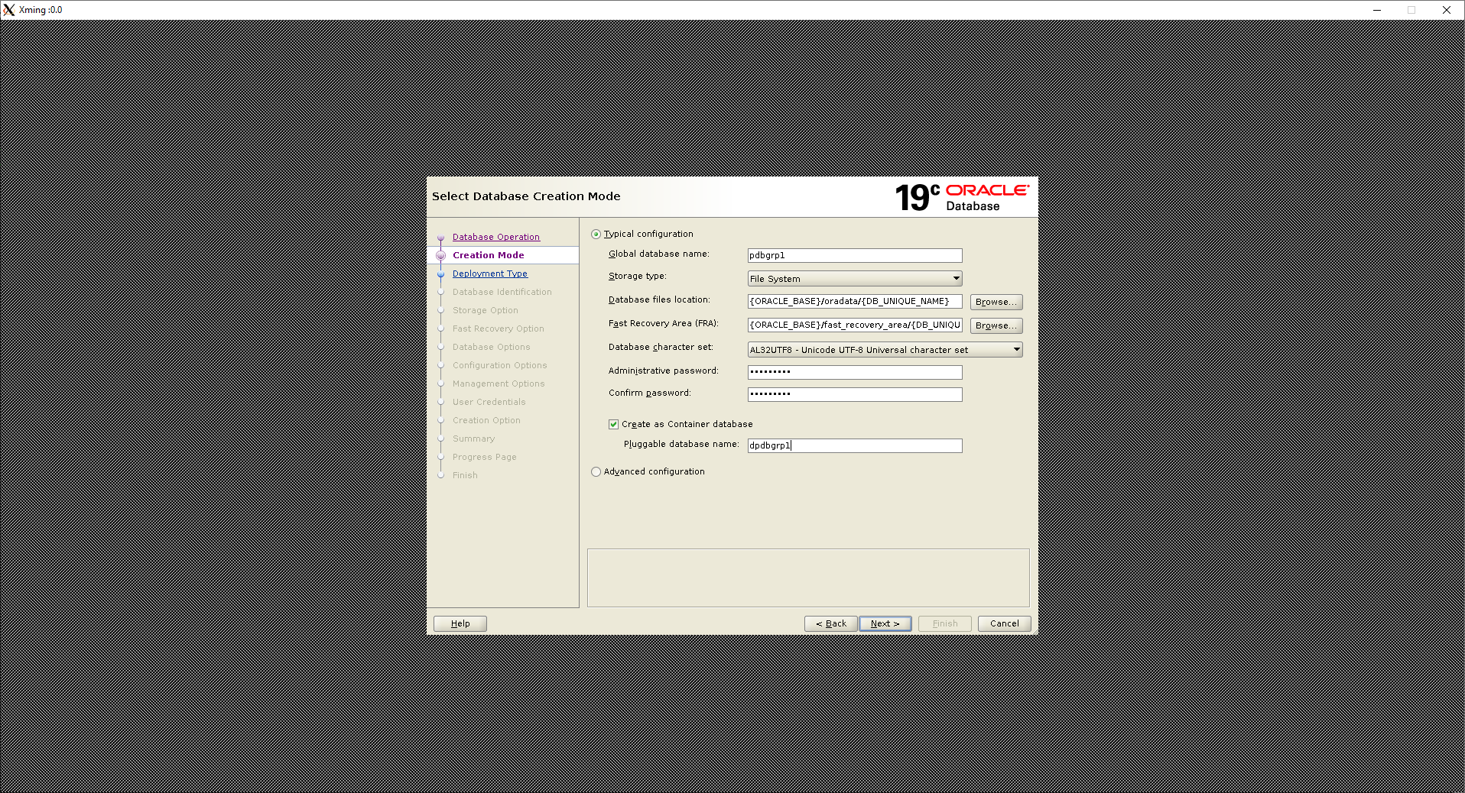

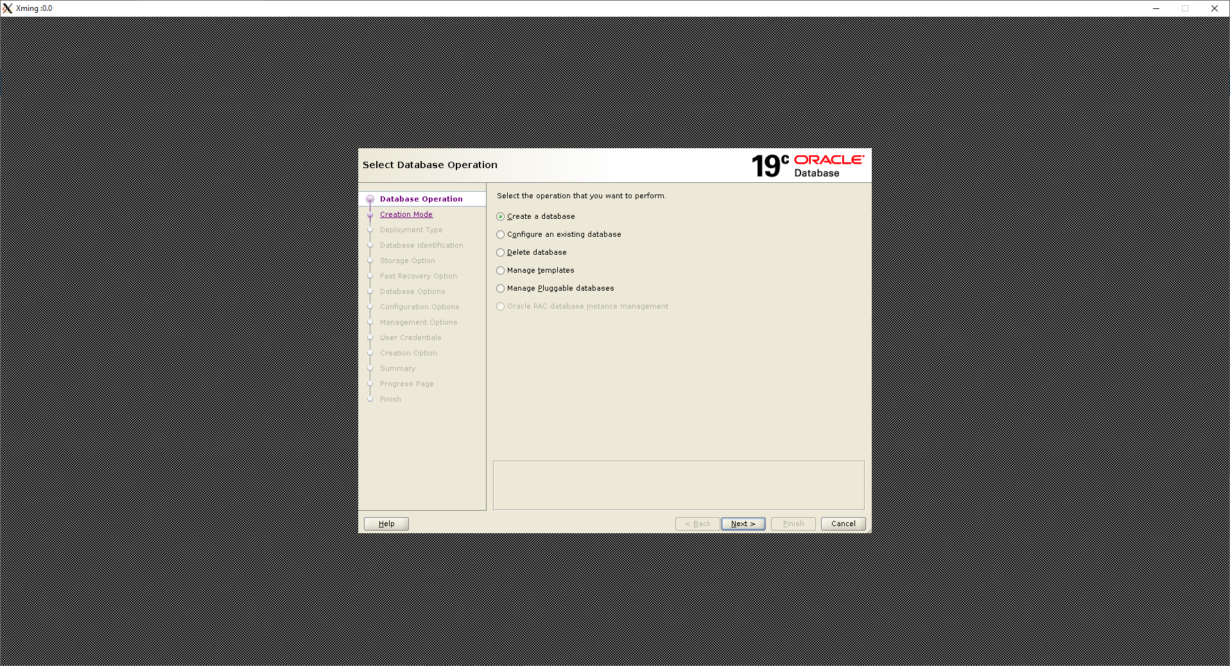

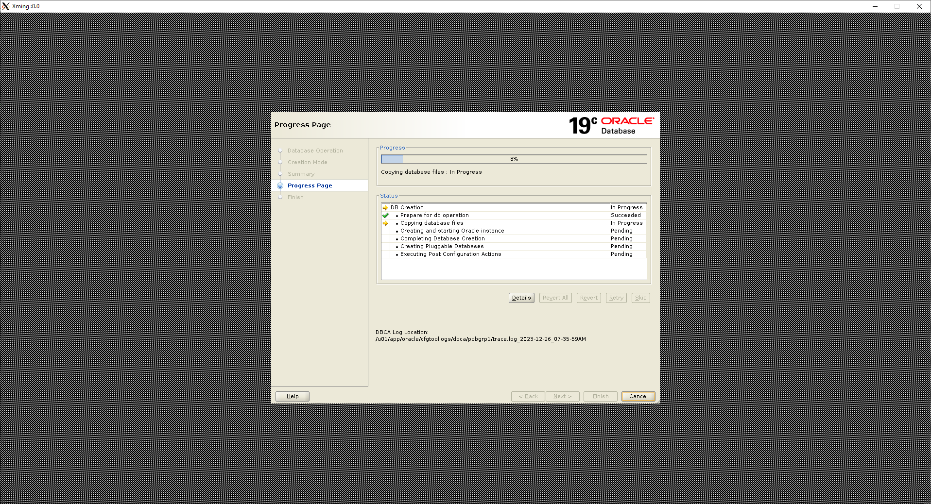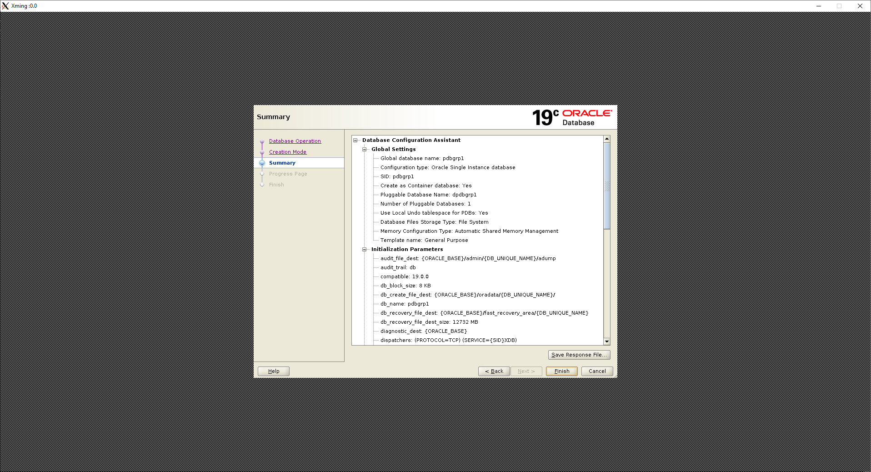

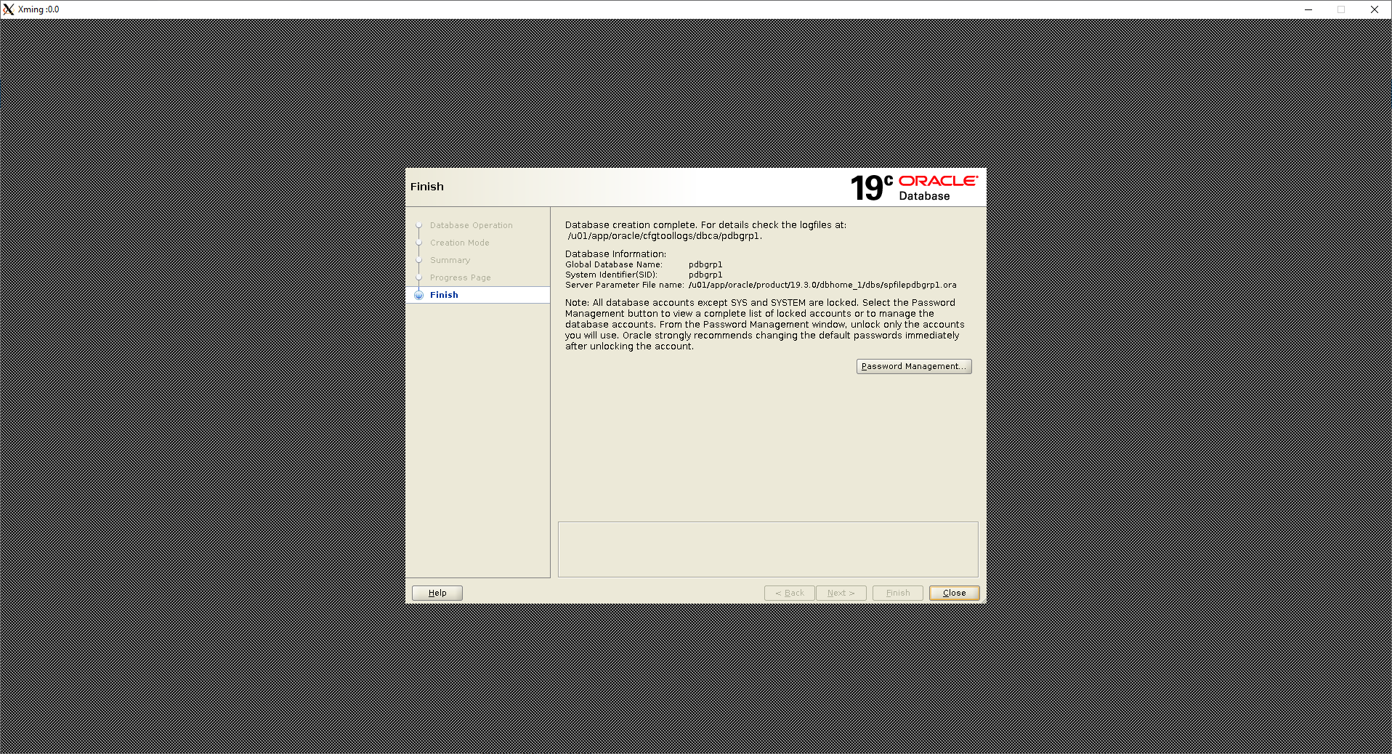

Database created successfully.

## **Configuring global variables**

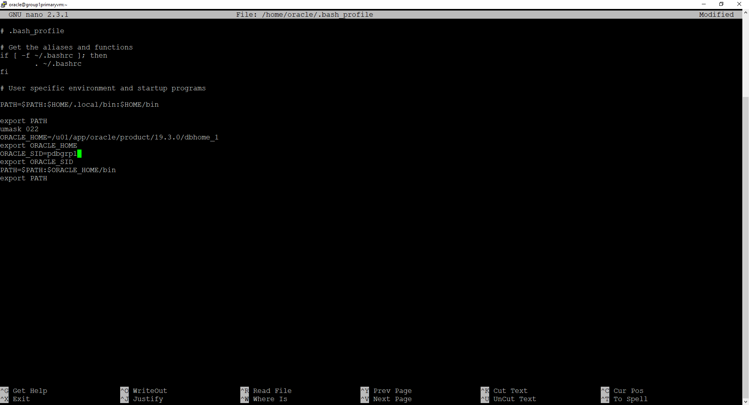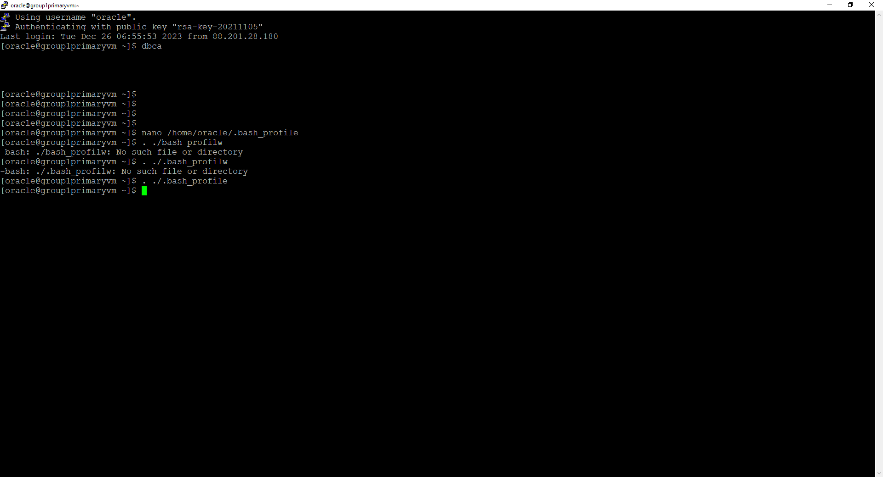inside the /home/oracle/.bash_profile, setting ORACLE_SID=pdbgrp1.

Creating a pluggable database “hrbdgrp1” using the DBCA in putty primary machine.

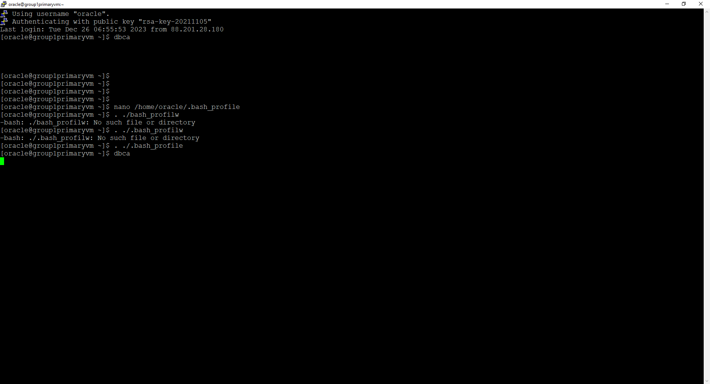

## **Managing data**

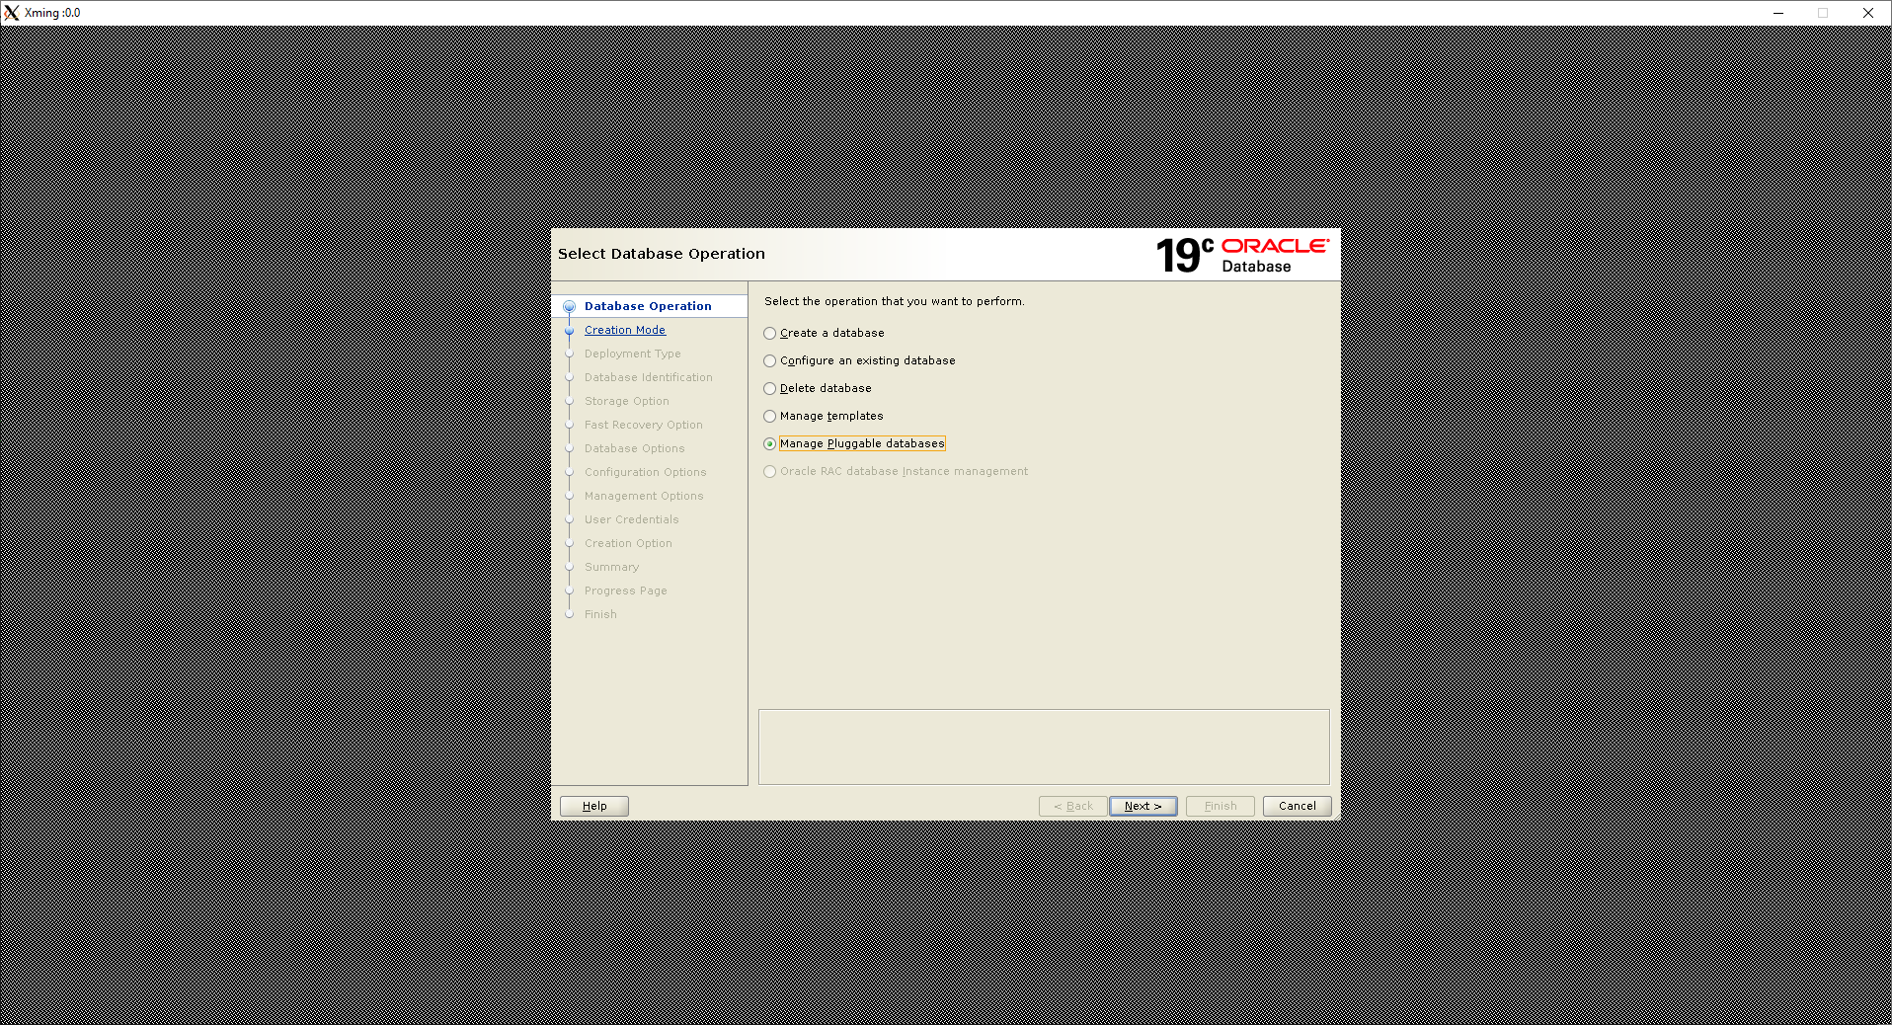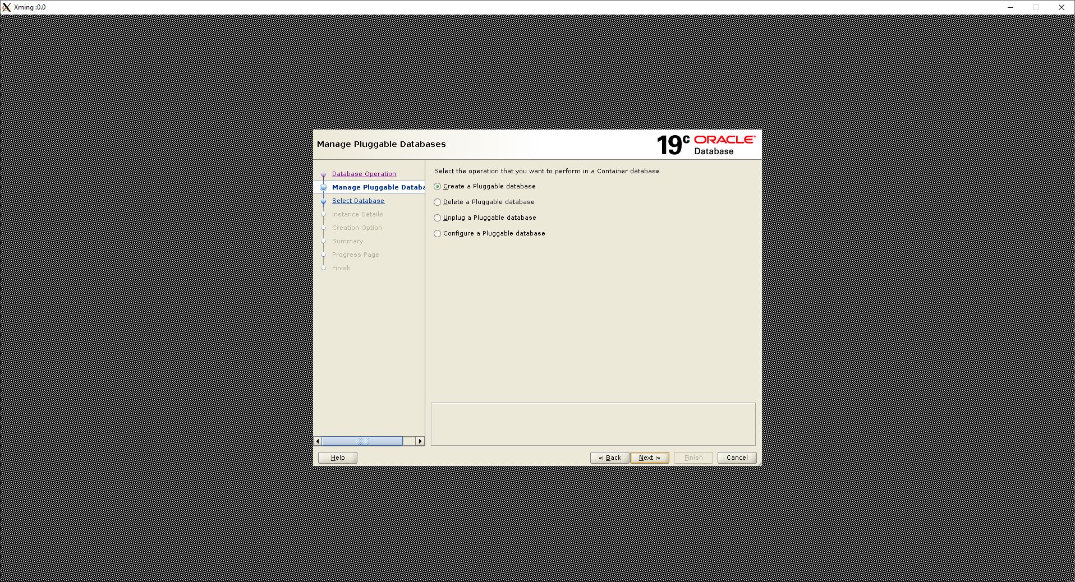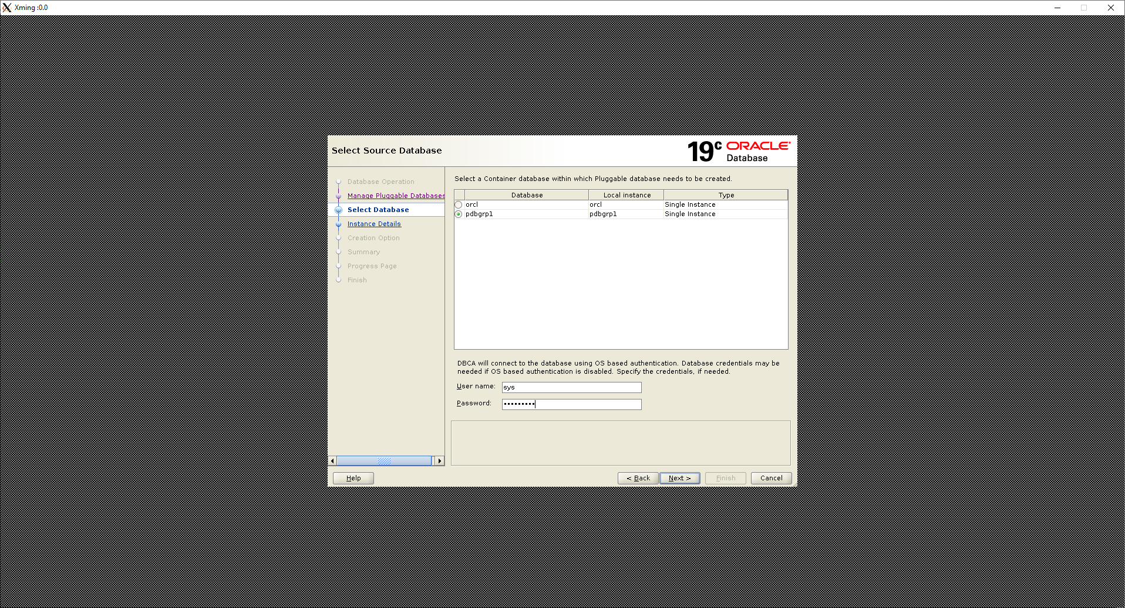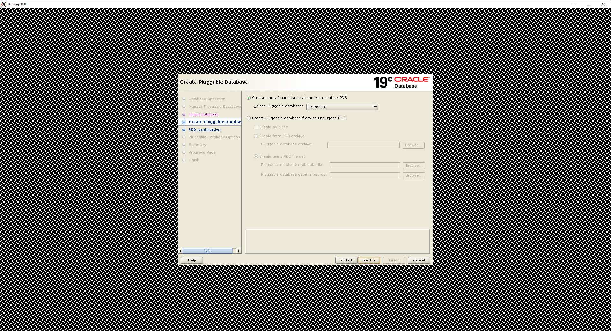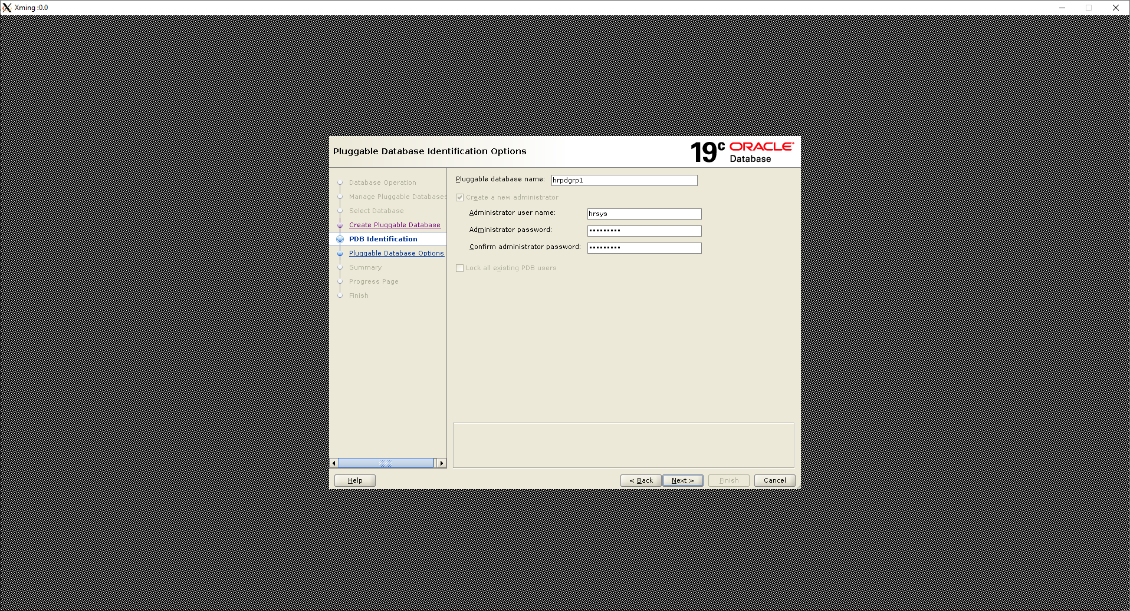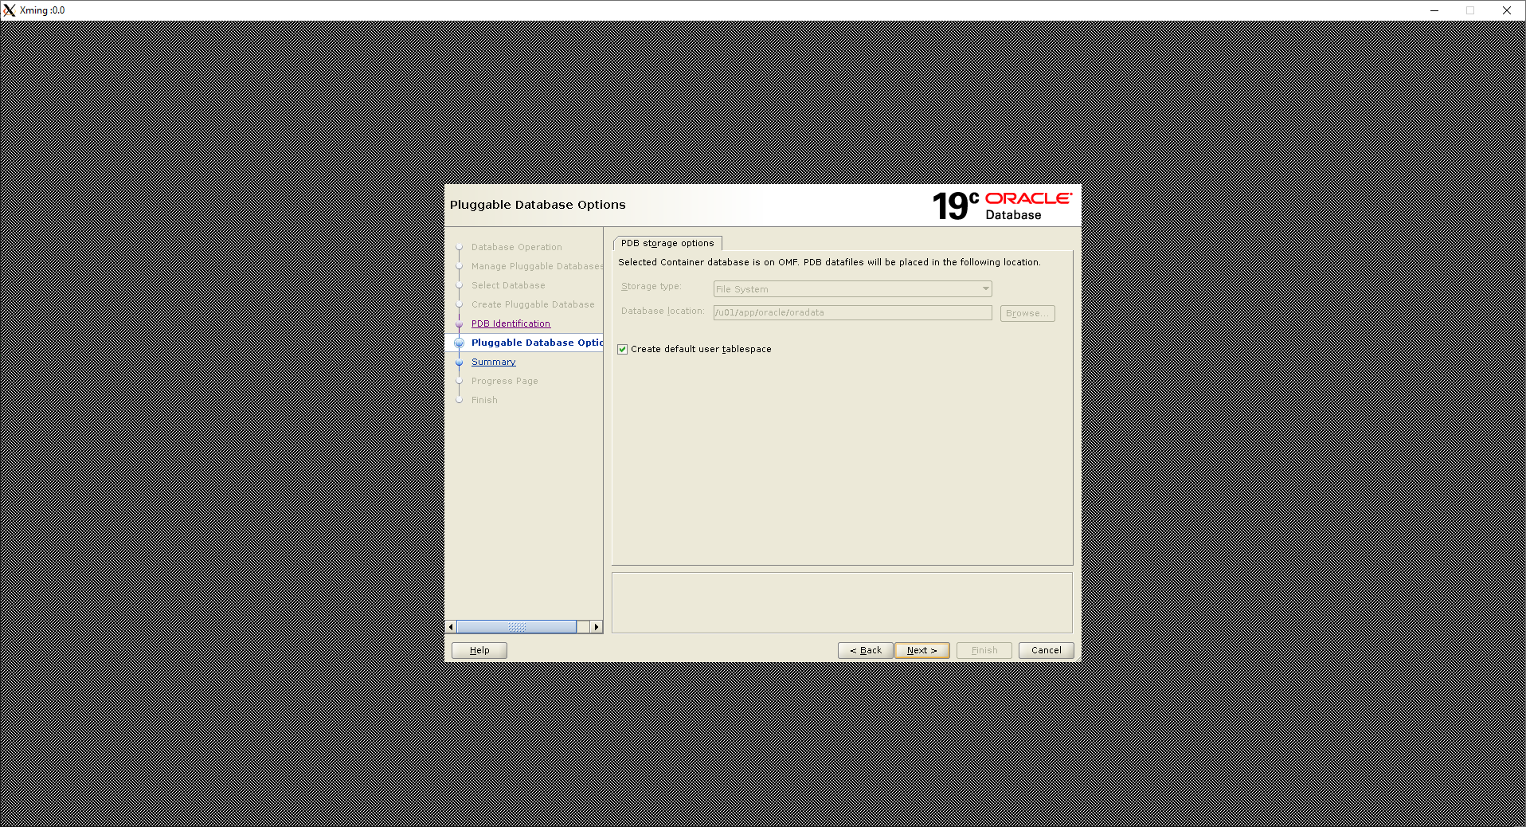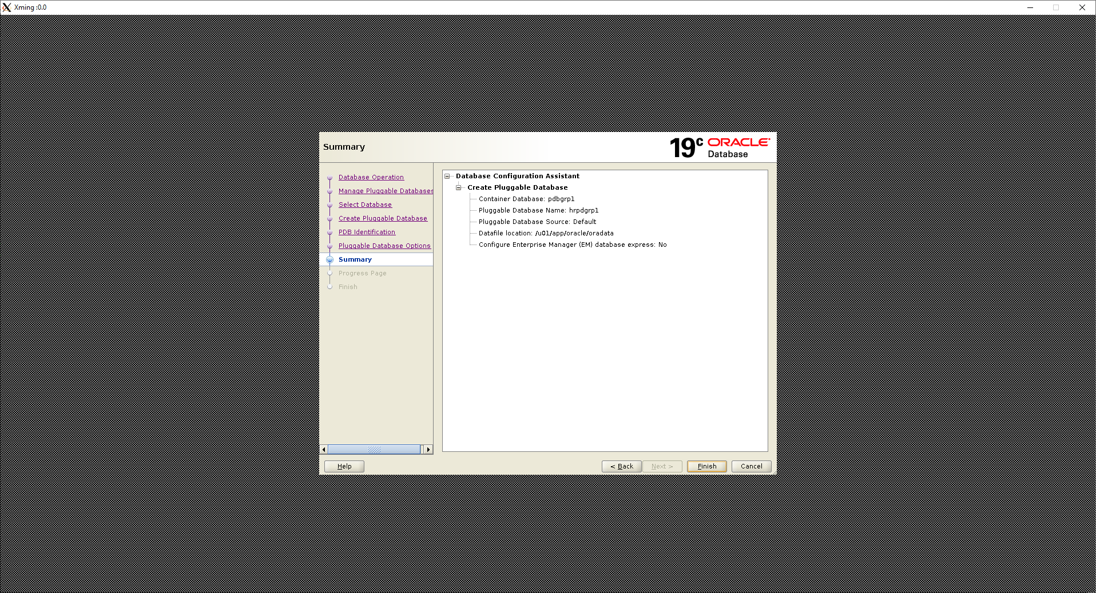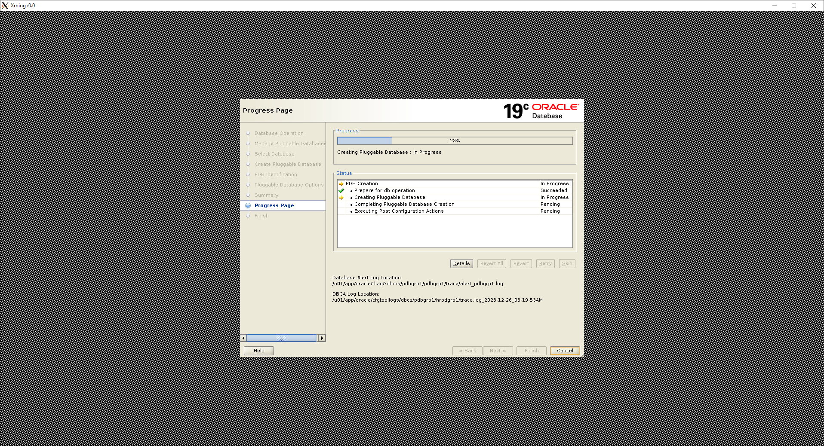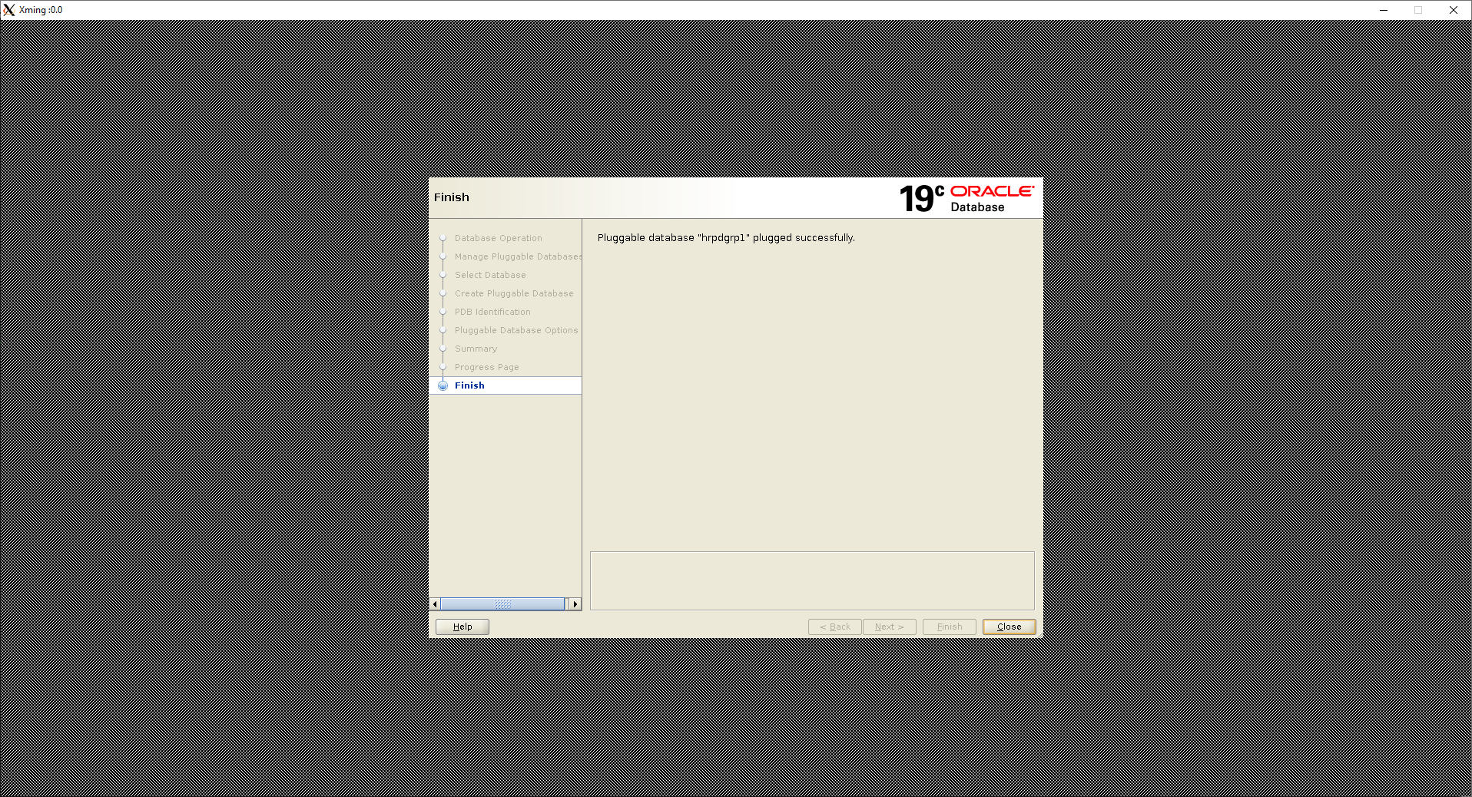

Pluggable database created successfully.

Inside sqlplus, showing available pdbs

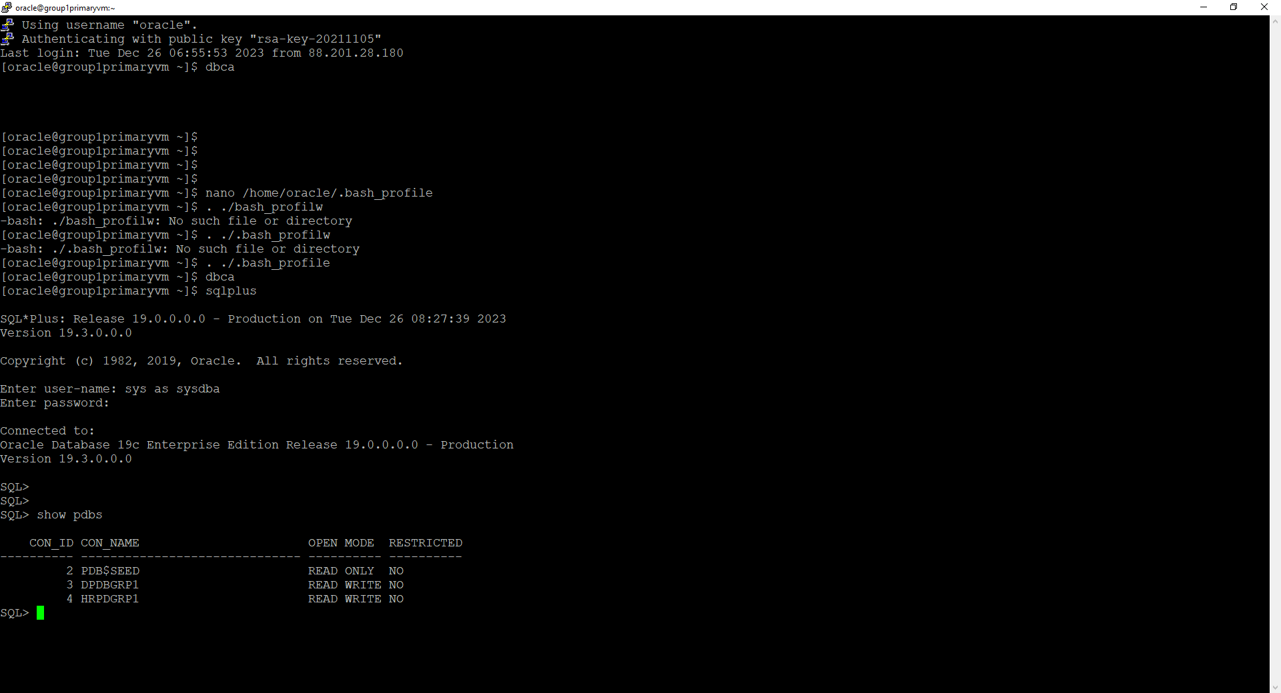

## **Creating separate disks**

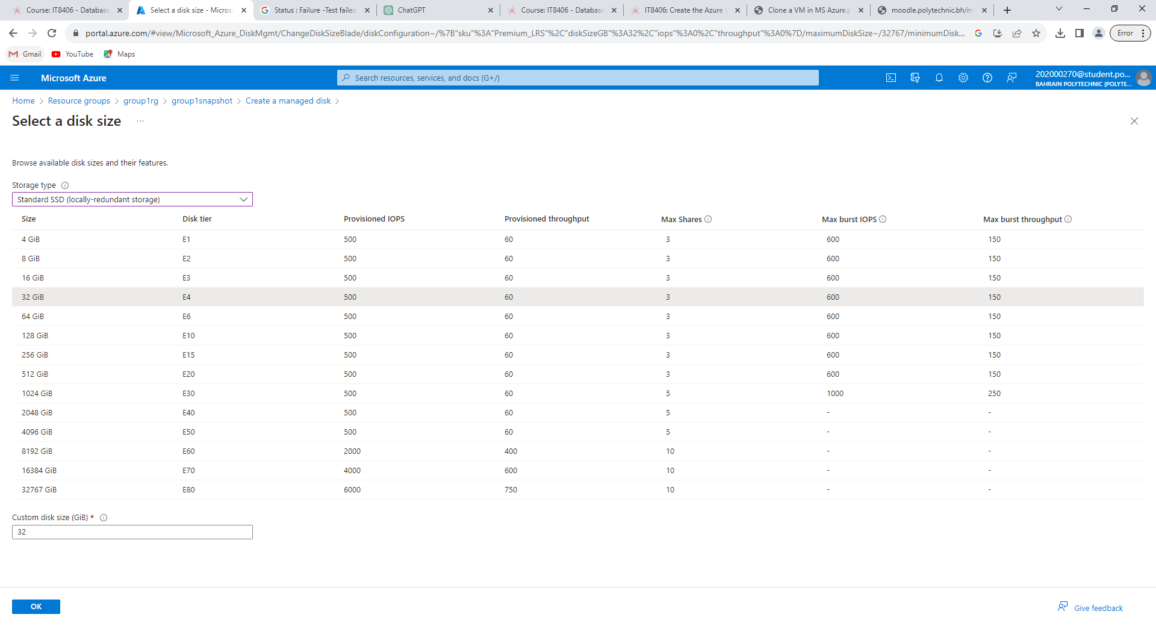

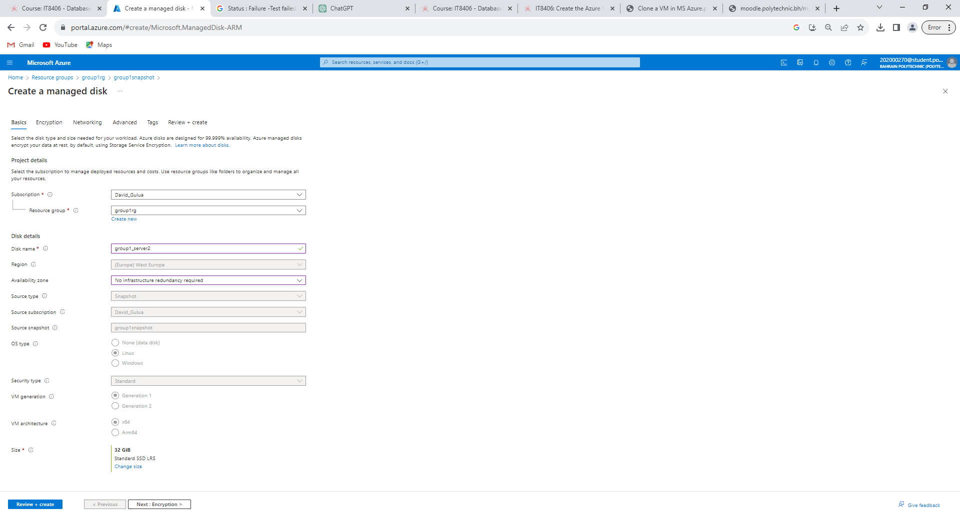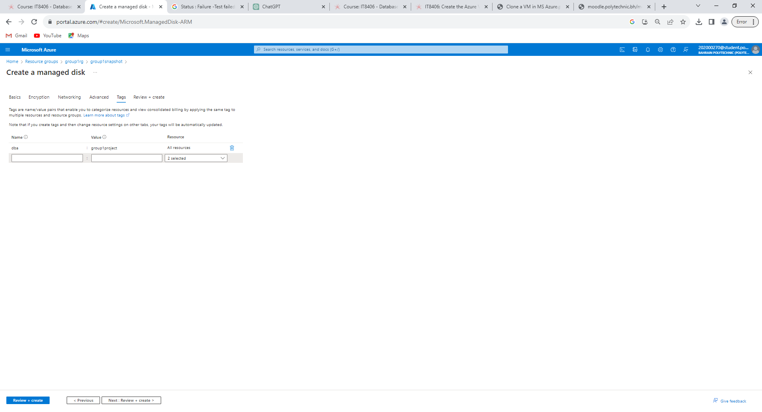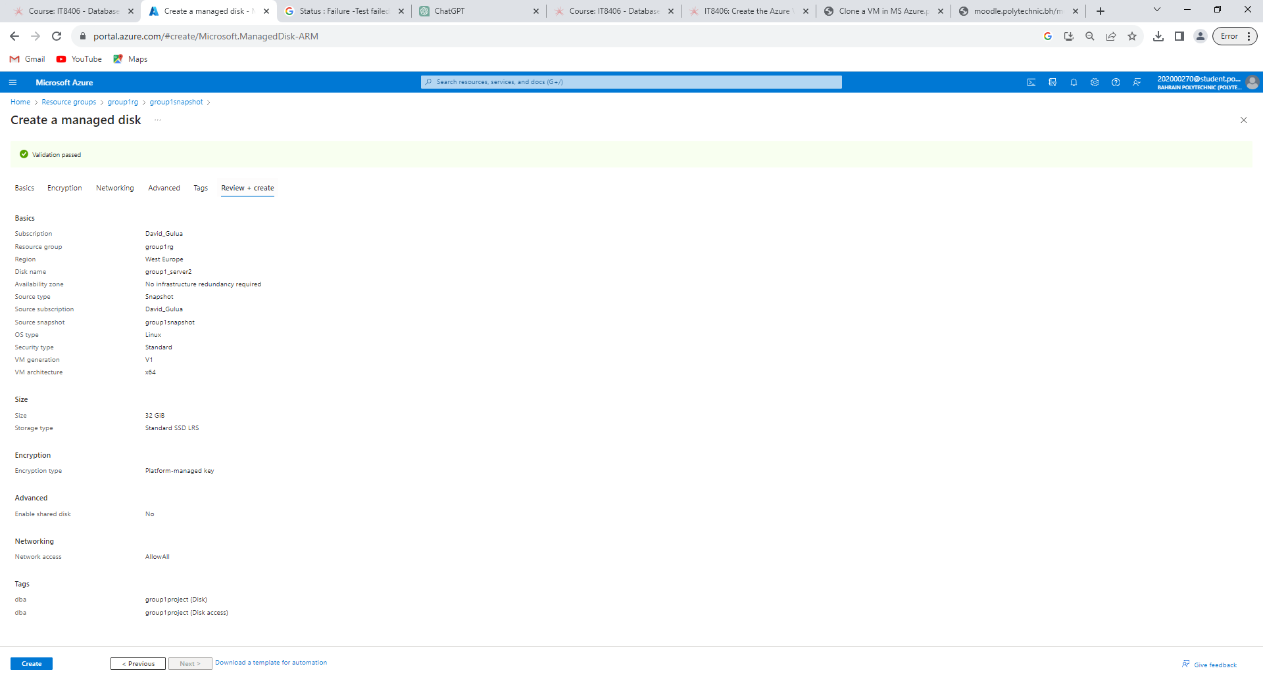

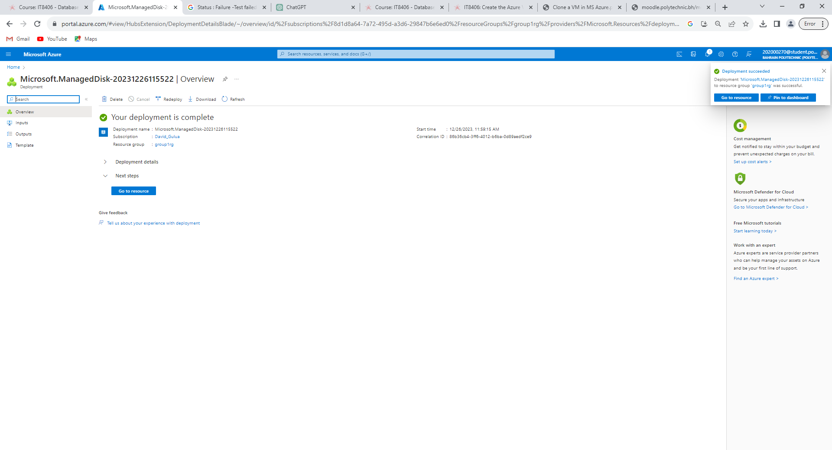

Available disks

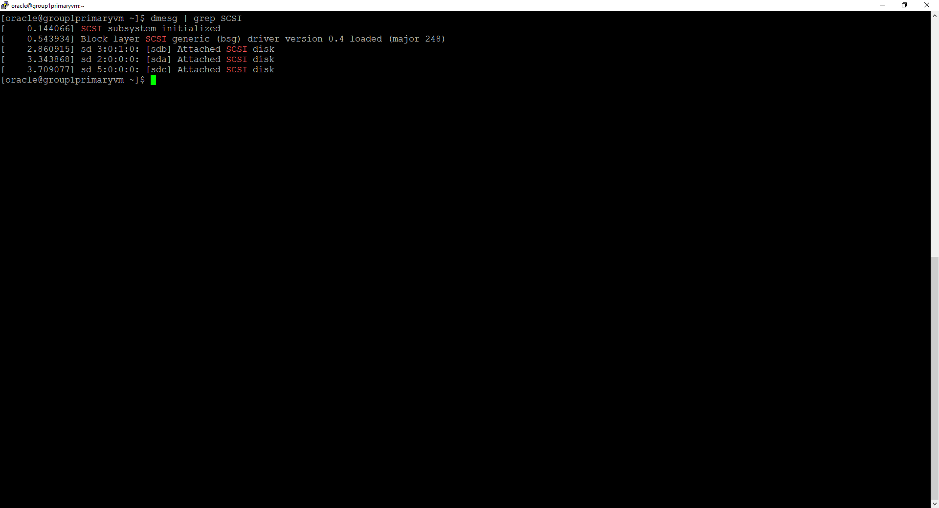

Partitioning “sdc”.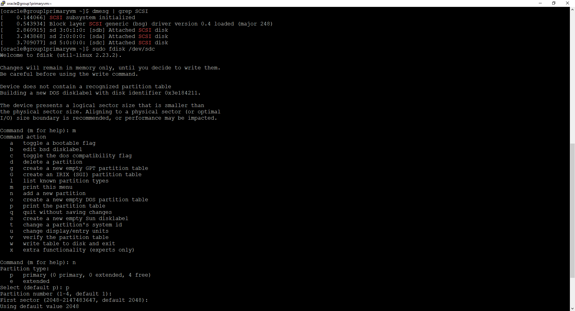

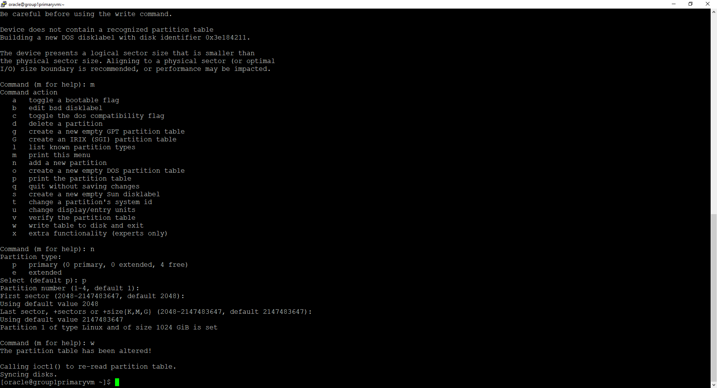

Formation the disk 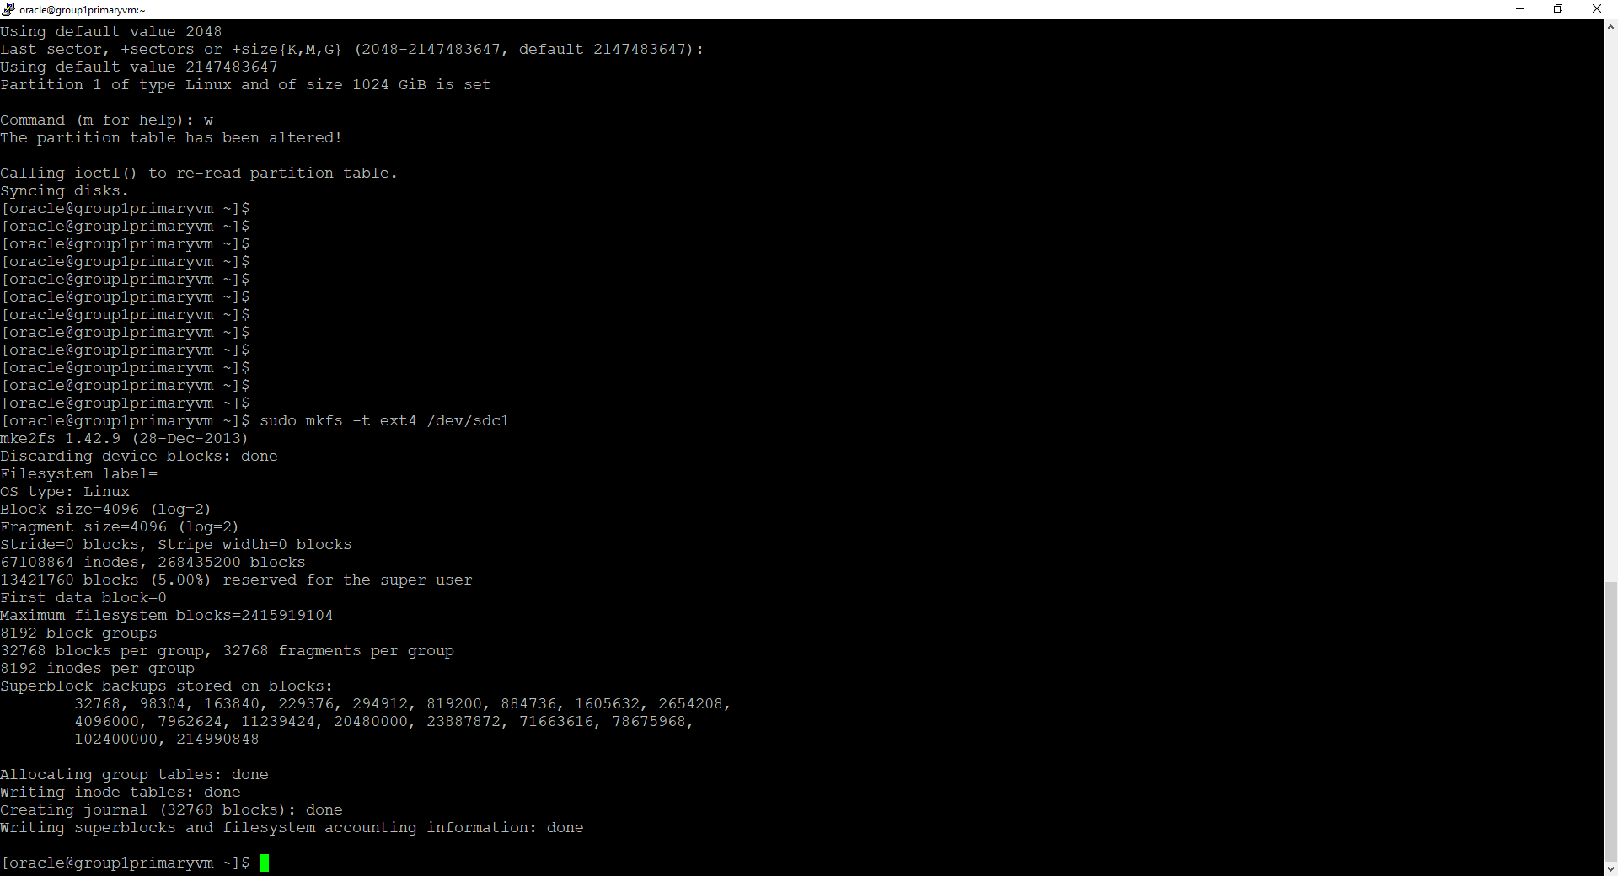

Making a directory /u02grp1_202002514

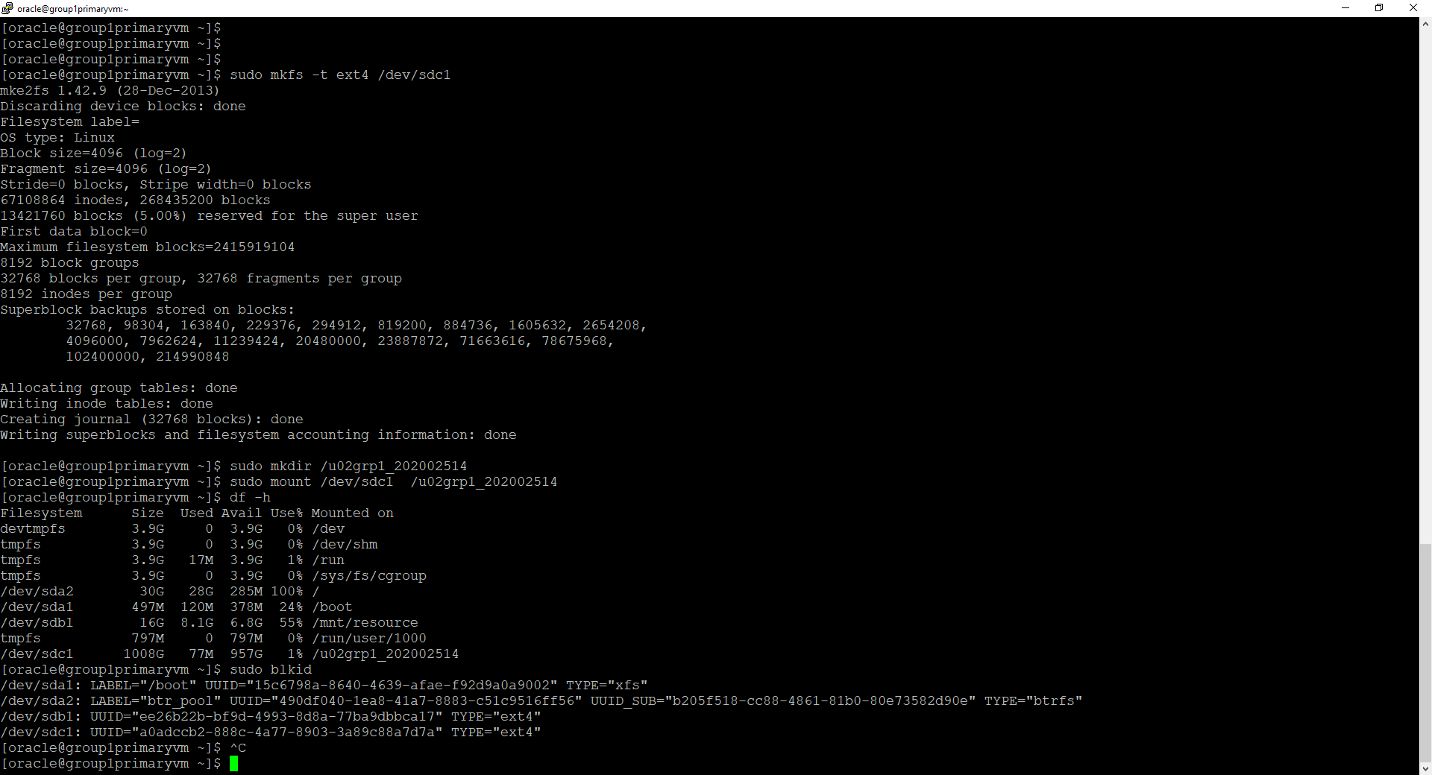

Checking new drive and location 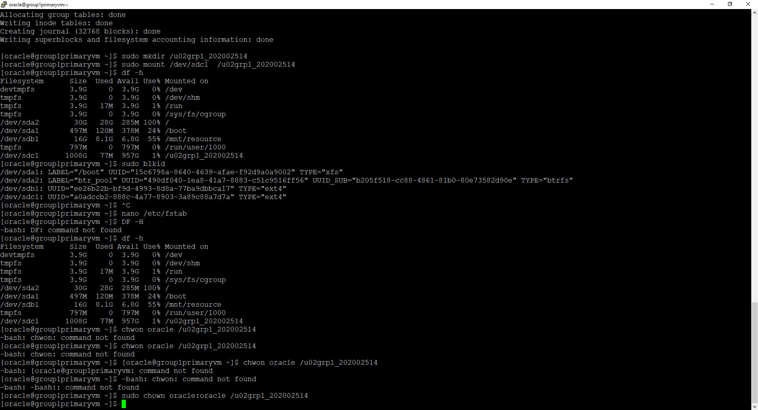

Make sure that drive is mounted by default and copy the UUID, then editing the fstab file, then make sure that the drive is present in the correct directory using df -h command, then oracle user is granted privileges to the new disk directory and finally using the dbca tool to create another database for environment testing called “testenvgrp1” and a pluggable database called “testenvpdbgrp1”.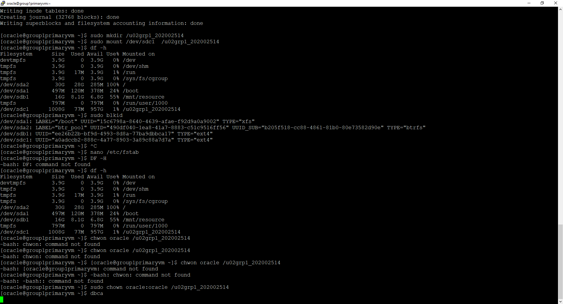

Database and Pluggable database are created successfully.

## **Tablespaces**

Online Orders and Delivery:

1-Manama branch disk (manamadisk) and tablespace (manamagrp1)

2-Riffa branch disk (riffadisk) and tablespace (riffagrp1)

Human Resources Planning

Employees and staff (hrdisk) and tablespace (hrgrp1)

## **Creating another three separate disks**

Creating disks , formatting, partitioning and granting privileges as before.

Riffa =sdf and path “data”

Hr =sdd and path “data1”

Manama =sde and path “data2”

## **Data Guard**

Database

## **Testing**

# **Project Reflection**

## Ameena: -

Working as a database administrator for a large delivery business allowed me to expand my knowledge and experience. This project helped me gain several skills as well as identify my strengths and weaknesses. some of the skills I had developed includes teamwork, the ability to analyze a company's problems and needs, find the most appropriate solution, design the project plan, estimate costs and how to upgrade a database system successfully.

I have discovered how to solve problems by researching and reading similar case studies to analyze data. In addition, I had managed my time to work on three projects in the same period by communicating effectively with my team members which they also have different schedules.

During the project, I overcame many obstacles to complete the project successfully and on time. For example, it was challenging to estimate the budget for the solution. Furthermore, I had to pay attention to every detail while completing the practical Implementation to finish it on time while having other important projects. Also, loading the DBCA page was slow, and we encountered errors even when our code was correct, which were resolved by refreshing the page.

In summary, this project gave me the opportunity to enhance my understanding and abilities and enabled me to determine what I am good at and what I need to improve. I will be able to use what I have learned in my future career. I strongly recommend having regular maintenance to improve the system, managers should consider training employees to be ready for any future failure and monitoring the system and alerting the database administrator if needed.

## Fedaa

## Maryam

# **References**

Data Intensity. (2023). AMERICAN INDUSTRIES® GROUP UPGRADES TO ORACLE DATABASE 19c TO ACHIEVE ENHANCED PERFORMANCE & SECURITY. Retrieved November 7, 2023, from Dataintensity.com website: <https://www.dataintensity.com/assets/casestudy/american-industries-group-upgrades-to-oracle-database-19c-to-achieve-enhanced-performance-and-security.pdf?v=3>

Hossain, A., & Shirazi, F. (2015, August 2). Cloud Computing: A Multi-tenant Case Study. Retrieved November 7, 2023, from ResearchGate website: <https://www.researchgate.net/publication/283261993_Cloud_Computing_A_Multi-tenant_Case_Study>

Layer, N. (2022, October 4). On-premise vs. cloud: differences and similarities. Retrieved October 23, 2023, from NordLayer website: <https://nordlayer.com/blog/on-premise-vs-cloud-differences/>

“Oracle (Active) Data Guard 19c". (2019). Oracle (Active) Data Guard 19c. Retrieved October 22, 2023, from Oracle.com website: <https://www.oracle.com/technetwork/database/availability/dg-adg-technical-overview-wp-5347548.pdf>

Oracle. (2018). Retrieved from Oracle.com website: <https://www.oracle.com/assets/technology-price-list-070617.pdf>

Oracle. (2023). Retrieved December 14, 2023, from Oracle.com website: <https://www.oracle.com/assets/processor-core-factor-table-070634.pdf>

Oracle DB Licensing Calculator - WintelGuy.com. (2016). Retrieved December 14, 2023, from Wintelguy.com website: <https://wintelguy.com/oracle-db-licensing-calc.pl>

‌